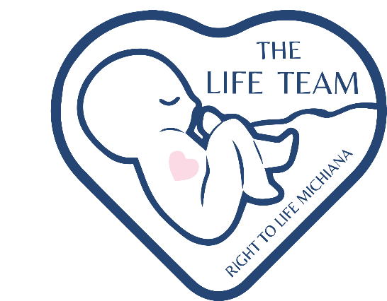

Outline for Teachers and Hosts

The Life Team of Right to Life Michiana is made up of community experts including mothers, fathers, teachers, medical practitioners, and other pro-life advocates.

A standard workshop is split into two segments, spanning about 45-60 minutes each, typically facilitated over two sessions or one extended session.

Part I is intended to convey an introduction to the science of fetal development, philosophical arguments concerning human life, non-graphic definitions of abortion and its local and national prevalence, legal background on critical cases, and a historical portrait leading up to current cultural attitudes about abortion.

Part II focuses on forming practical support for moms and babies with interactive training equipping students with an understanding of challenges experienced during an unplanned pregnancy, education on local resources available to meet the challenges faced, real-life scenarios preparing students with practical tools to respond to a pregnancy in a crisis with love and support and opportunities to address questions concerning all the tough cases.

An outline of the Life Team Workshop is available for your reference below. The Life Team is prepared to adjust the content and timing of workshops to meet the needs of each group.

This workshop is suitable for classrooms (eighth grade and up), middle-school and high-school youth groups, and adult church groups.

**Part I: Fetal Development and Abortion**

1. Fetal development
   1. Stages of development from fertilization to birth in a typically developing pregnancy (fetal models and images of preborn children at various gestational ages are shared)
   2. Ultrasound technology
   3. Stages of development continuing beyond birth
   4. Atypical development during pregnancy
      1. Miscarriage
2. Non-essential differences between human beings at various stages of development
   1. Size
   2. Level of Development
   3. Environment
   4. Degree of Dependency
3. Abortion: the intentional termination of a human pregnancy
   1. Methods and risks
      1. Brief definition of chemical and surgical abortion procedures (no images or graphic content are shared)
   2. Two critical cases concerning abortion
      1. *Roe v. Wade*
      2. *Doe v. Bolton*
   3. The importance of just laws
      1. Historical cases in which unjust laws have led to misunderstandings about the value of human life
   4. Recent legal developments
      1. *Dobbs v. Jackson Women’s Health Organization*
         1. Authority of each branch of government
      2. Indiana SEA 1
         1. Abortion’s past in our local community
         2. Current state of abortion in northern Indiana
   5. Abortion’s impact over 50+ years
      1. An audio representation

**Part II: Practical Support for Moms and Babies**

1. Brief review of Part I content
   1. Opportunity for questions of The Life Team
2. Understanding the challenges experienced during an unplanned pregnancy
   1. Group critical thinking exercise
3. Local resources available to meet families’ needs
   1. Women’s Care Center
   2. HerMichiana
   3. Hannah’s House
   4. Project Rachel
4. Handling real-life scenarios
   1. Role-playing
   2. Analysis and discussion
5. How to make a difference
   1. Take-home resources

Copyright © 2023, Right to Life Michiana. All rights reserved. No part of The Life Team Workshop may be reproduced or transmitted in any form or by any means, electronic or mechanical, including photocopying, recording, or by any information storage and retrieval system, without permission in writing from Right to Life Michiana. All inquiries should be addressed to: Right to Life Michiana, 2004 Ironwood Circle, Suite 130, South Bend, Indiana 46635.